Lab 03 - NAND Only Logic
In this lab, you’ve learned how to convert arbitrary logical equations into NAND only circuits, and why that might be a good thing.

Rubric

Item | Description | Value
Summary Answers | Your writings about what you learned in this lab. | 25%
Question 1 | Your answers to the question | 25%
Question 2 | Your answers to the question | 25%
Question 3 | Your answers to the question | 25%

Lab Summary
This Lab focuses on the physical aspects of digital logic, and gives form and function to the theory that we have learned so far. In the case of this lab, we are given the equation (A & ~B) | (C & D), and we must convert it to NAND gates in order to get the physical circuit to function. The conversion was the easy part, the task of creating it on a breadboard was much harder. This is where the Chip Pinout diagram really helped, as I found myself lost more than once putting the wires into the right spot on the board. Here is a photo of the completed board to demonstrate my learning:
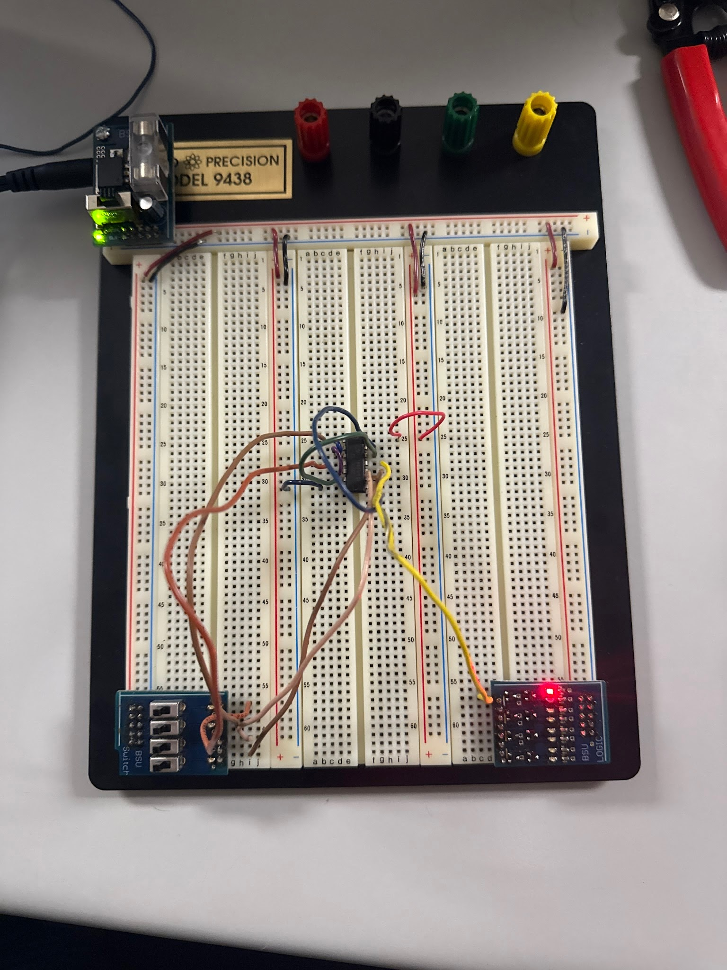
Photo Of Completed Breadboard

Lab Questions

1 - Write down DeMorgan’s Law and the truth tables proving it out.
DeMorgan’s Law consists of these two rules when it comes to Boolean algebra:
Rule 1 (NAND Conversion): ~(A & B) = ~A + ~B

A | B | A * B | ~(A * B) | ~A | ~B | ~A + ~B
0 | 0 | 0 | 1 | 1 | 1 | 1
0 | 1 | 0 | 1 | 1 | 0 | 1
1 | 0 | 0 | 1 | 0 | 1 | 1
1 | 1 | 1 | 0 | 0 | 0 | 0
Rule 2 (NOR Conversion): ~(A + B) = ~A & ~B

A | B | A + B | ~(A + B) | ~A | ~B | ~A & ~B
0 | 0 | 0 | 1 | 1 | 1 | 1
0 | 1 | 1 | 0 | 1 | 0 | 0
1 | 0 | 1 | 0 | 0 | 1 | 0
1 | 1 | 1 | 0 | 0 | 0 | 0

2 - What is the value in converting circuits to NAND only?
NAND is a Universal Gate, which means that any logic function can and usually is constructed using only NAND gates. This allows, in our case, for the use of only one chip instead of multiple separate chips with different logic gates, streamlining our process.

3 - How does what you did in lab with the breadboard relate to the FPGA?
The Breadboard is just a physical representation of the same task we undertake using an FPGA, the difference being we physically hardwire everything to create our logic on a breadboard, while in Vivado, we use verilog code and input effectively the same things, just digitally instead of manually. The same digital logic applies to both systems regardless of its state of nature.

Code Submission
Upload a .zip of all your code or a public repository on GitHub.

